Help WF – Hide reprove button from My Inbox App

Enter SPRO transaction, Button IMG.
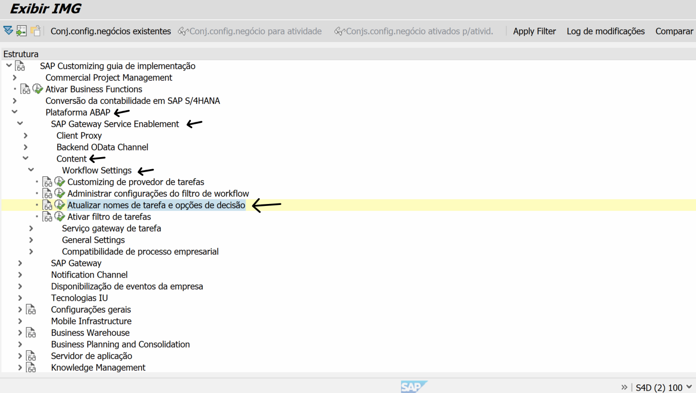
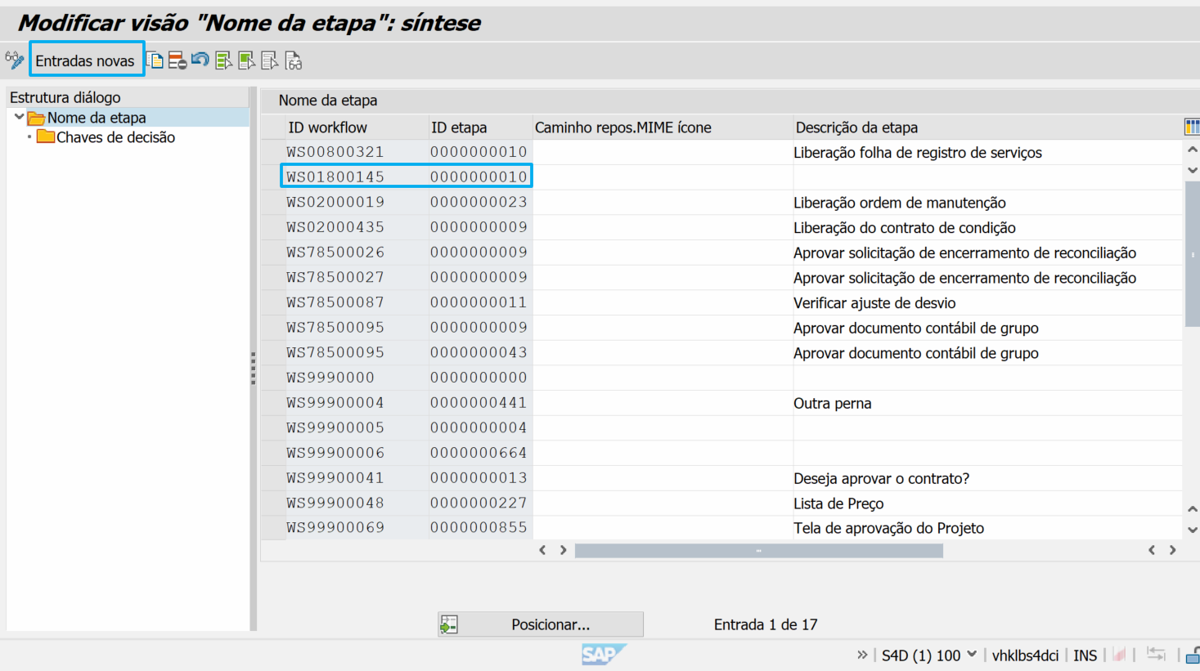

Add your workflow and step
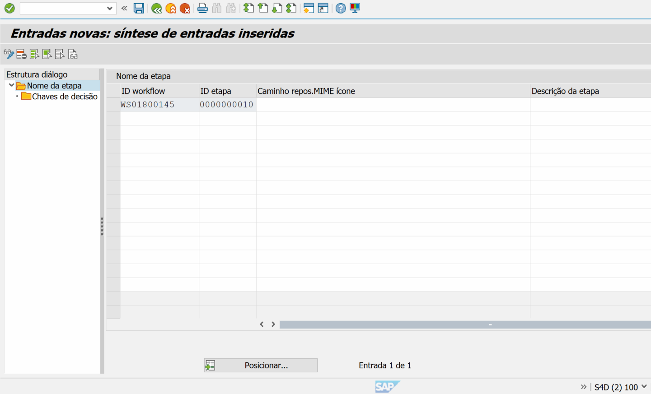

Select your workflow line, and click Chaves de Decisão folder.
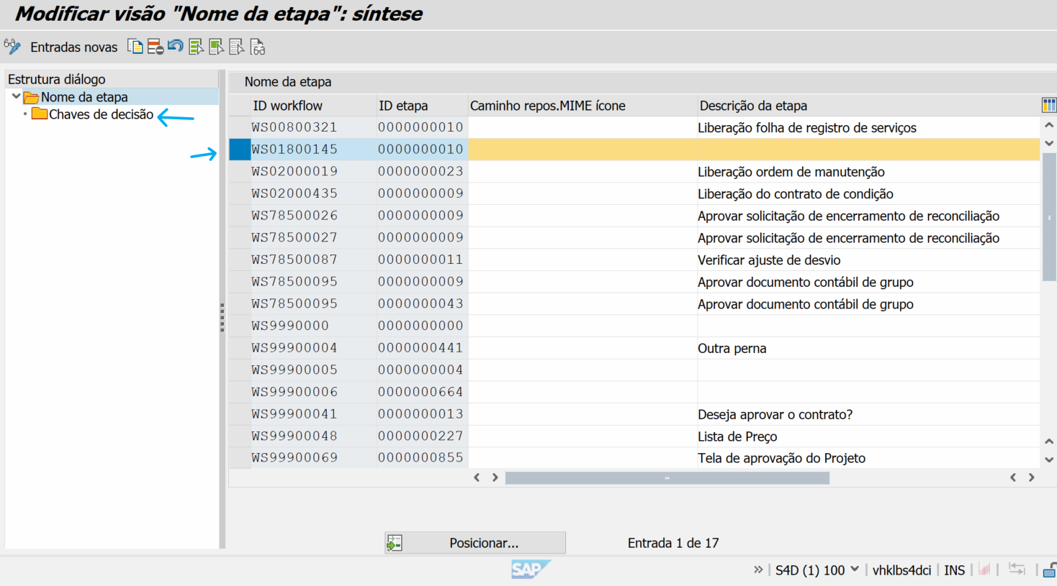

Add names for buttons you want (and do not add the reprove button).
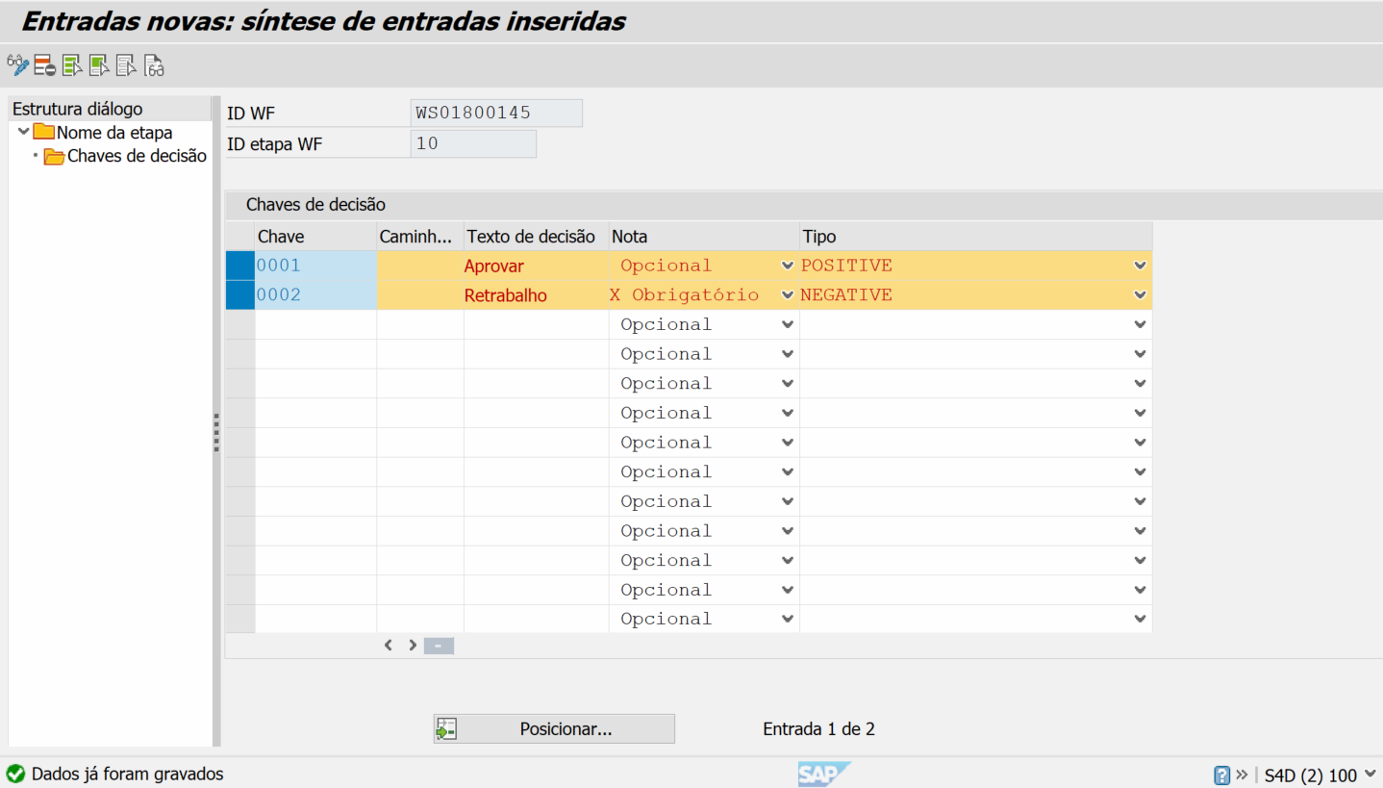

Execute SCC1 to copy your Customizing request to test environment
See the result in My inbox
The Reprove button is hidden.
